Log into Frontline Using a Computer/Laptop
- Navigate to the Frontline platform.
  - Using the district website
    - Go to wcskids.net
    - Hover over the Employee button on the right-hand side.
    - Under Quick Links click on Aesop/Frontline
- On the Frontline main page enter your Username and Password, click sign in.

- Absence Management (AESOP) is the default platform for an employees’ homepage.
- If it is not, on the employee Frontline homepage, click on the drop down next to the employee’s name then choose Absence Management
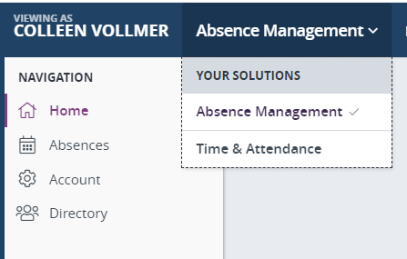

- To create an absence, click on the date(s) the absence is needed.
- On the pop-up box click the create absence button
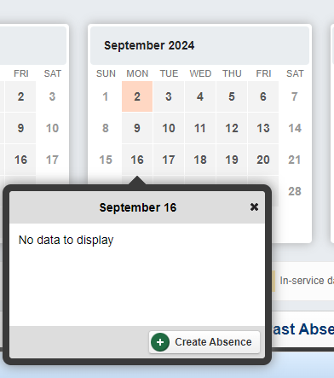
- Click on Advanced Mode
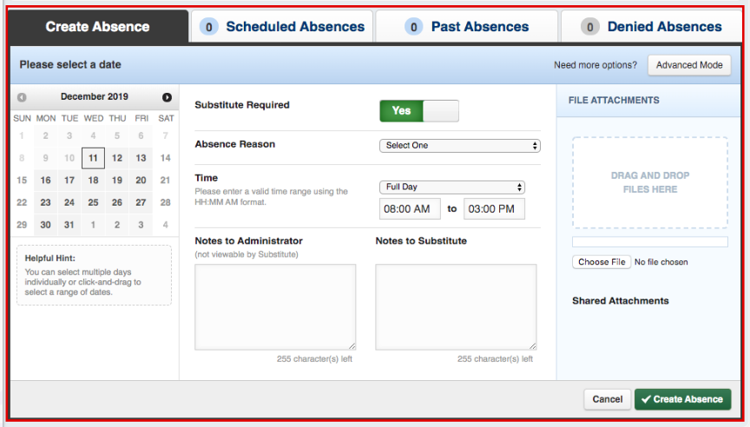
- Complete the information on the Create Absence Tab
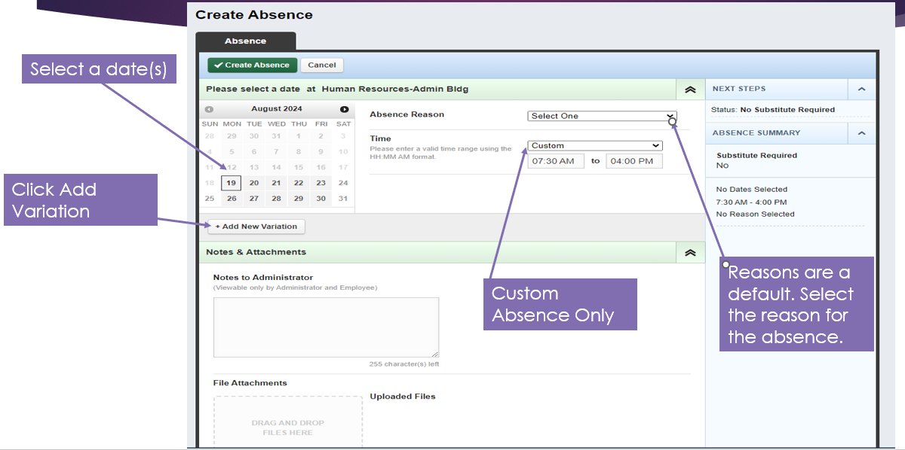

  - All transportation employees will choose custom absence in the first drop down in the “Time” section. Due to the make-up of the driver’s routes, the full day or half day option is not feasible.
  - For each route time you are missing, you will need to enter a variation. For example, if you are missing your morning and end of day shift, but not your mid run, you will need to create a separate variation for each; the morning run, and end of day run.
For example, if you are missing your whole day, you will create 3 variations: one for each of your runs.
- For a custom absence you will enter the start and stop of the run.
- Once finished filling in all the detail information and need to add another variation; click add variation. This is where you will add an additional run that you need to be out for.
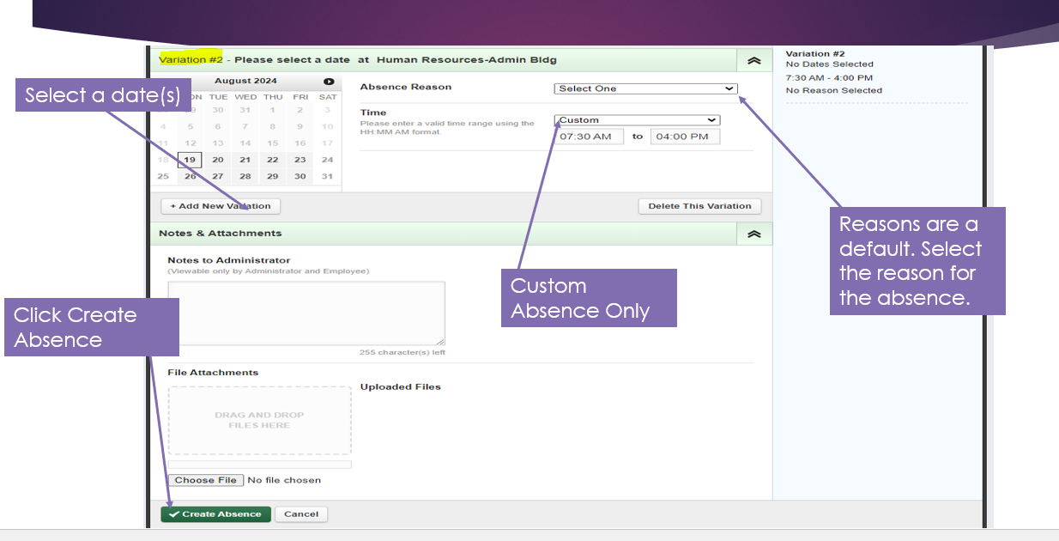
- Click Create Absence in the bottom left corner.
- You will then get a confirmation number, Click OK 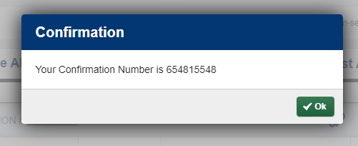
- You are all set and have now created your absence.

Log into Frontline Using the Frontline App
- Download the Frontline Education App (Separate Instructions also provided)
  - Go to your phone app store.
  - Search Frontline Education
  - Follow your phone’s download instructions.
  - Open App and click Get Started
- Open the Frontline App
- Log into the Frontline platform using your Username and Password
- An absence can be created using two options.
  - Directly from the home page (as seen in the first image)
  - Access the Menu and select the Absences option (as seen in the second image)
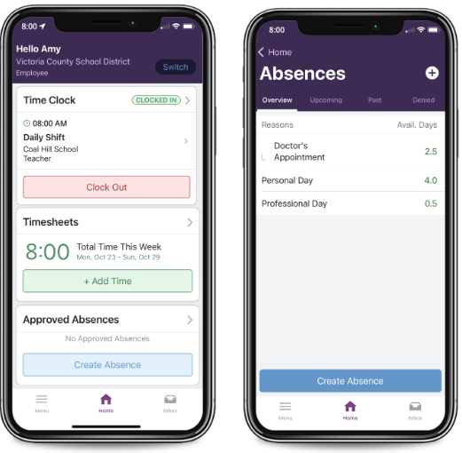
- Complete the information page.
  - Why: choose a reason for the absence; the click the arrow at the bottom right of the app
  - When: choose the date(s)
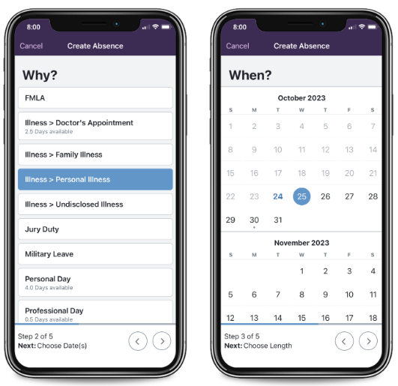

  - How long: this is where you will choose custom; choose the start and end time. Then arrow to the right
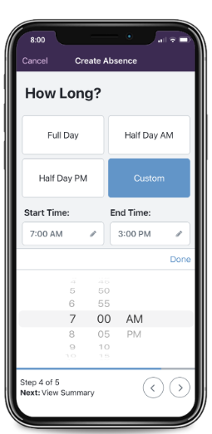
- Substitute will always say NO. Bus driver subs are not assigned through Aesop
- Review: if all information is correct click on the Green Submit Absence button
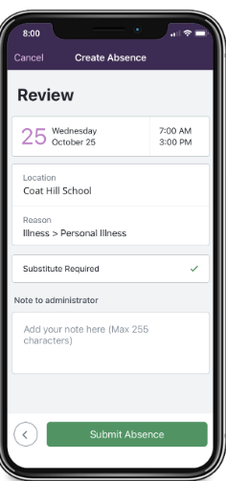
- Absence is now created.
IMPORTANT: Phones MUST be connected to Wi-Fi to use the App.
Locations MUST be enabled to use the App.

